**VIT-AP UNIVERSITY, ANDHRA PRADESH**

**CSE3003 – Computer Networks - Lab Sheet: 7**

**Academic year:** 2023-2024  **Branch/ Class:** B.Tech

**Semester:** Fall  **Date:**

**Faculty Name:** Prof. S.Gopikrishnan  **School:** SCOPE

**Student name:Aman Sahu Reg. no.: 22BCE7224**

**LAB 7**

1. Design and configure a network using RIP Routing protocol.

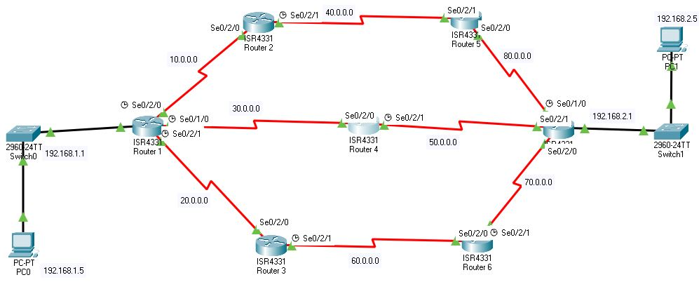

Objectives:

1. Design a network using seven routers and switches with one source and one destination PC
2. Configure all the routers with RIP routing.
3. Verify the connectivity.

Addressing Table:

|  |  |  |  |
| --- | --- | --- | --- |
| Device | Interface | IP Address | Subnet Mask |
| PC1 | NIC | 192.168.1.5 | 255.255.255.0 |
| PC2 | NIC | 192.168.2.5 | 255.255.255.0 |
| Router 1 gi 0/0/0 |  | 192.168.1.1 | 255.255.255.0 |
| Router 1 Serial 0/2/0 |  | 10.0.0.1 | 255.0.0.0 |
| Router 1 Serial 0/2/1 |  | 20.0.0.1 | 255.0.0.0 |
| Router 1 Serial 0/1/0 |  | 30.0.0.1 | 255.0.0.0 |
| Router 2 Serial 0/2/0 |  | 10.0.0.2 | 255.0.0.0 |
| Router 2 Serial 0/2/1 |  | 40.0.0.1 | 255.0.0.0 |
| Router 3 Serial 0/2/0 |  | 20.0.0.2 | 255.0.0.0 |
| Router 3 Serial 0/2/1 |  | 60.0.0.1 | 255.0.0.0 |
| Router 4 Serial 0/2/0 |  | 30.0.0.2 | 255.0.0.0 |
| Router 4 Serial 0/2/1 |  | 50.0.0.1 | 255.0.0.0 |
| Router 5 Serial 0/2/0 |  | 80.0.0.1 | 255.0.0.0 |
| Router 5 Serial 0/2/1 |  | 40.0.0.2 | 255.0.0.0 |
| Router 6 Serial 0/2/0 |  | 60.0.0.2 | 255.0.0.0 |
| Router 6 Serial 0/2/0 |  | 70.0.0.1 | 255.0.0.0 |
| Router 7 Serial 0/2/0 |  | 70.0.0.2 | 255.0.0.0 |
| Router 7 Serial 0/2/1 |  | 50.0.0.2 | 255.0.0.0 |
| Router 7 Serial 0/1/0 |  | 80.0.0.2 | 255.0.0.0 |
| Router 7 gi 0/0/0 |  | 192.168.2.1 | 255.255.255.0 |

Expected output screenshots:

* 1 success communication
* 7 router configuration screenshots

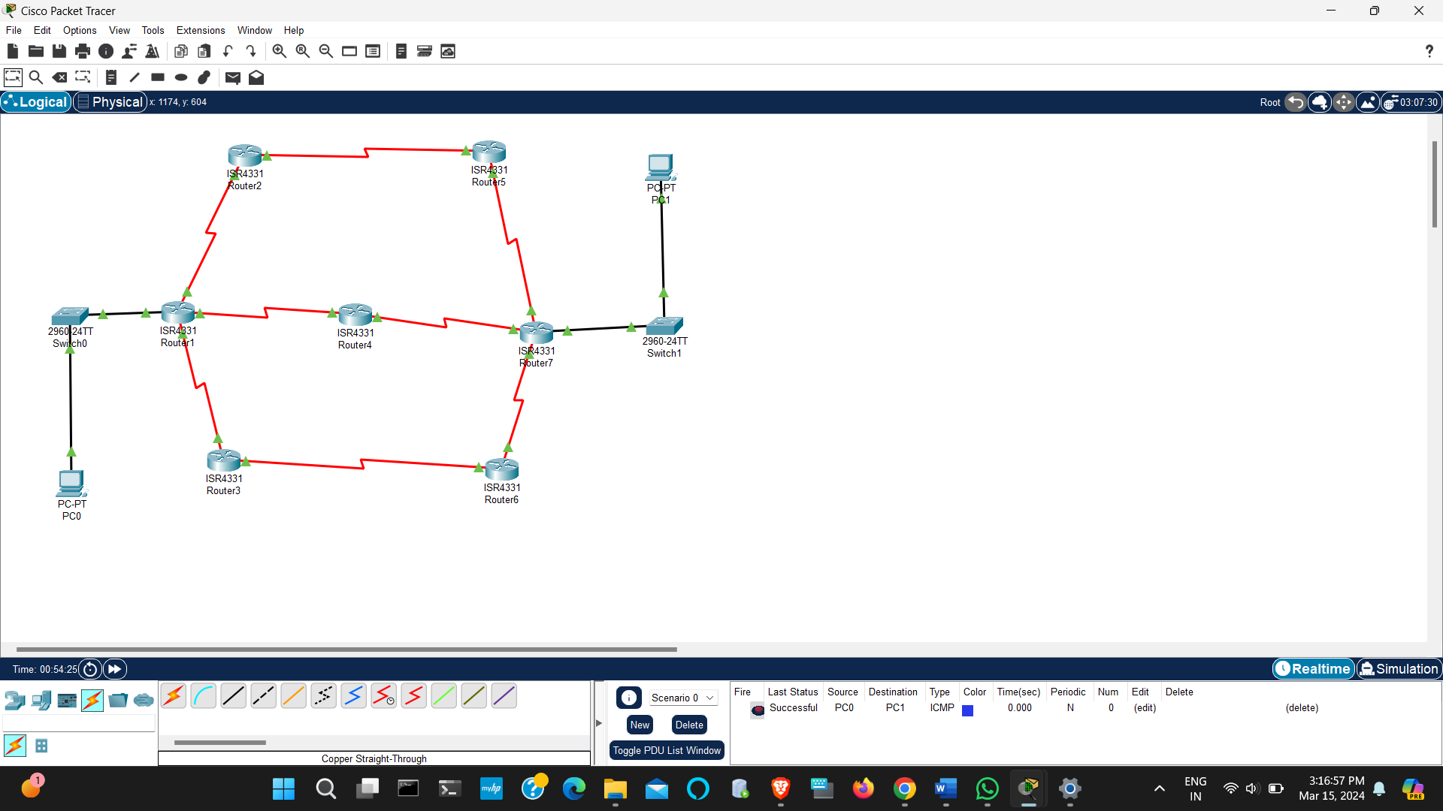

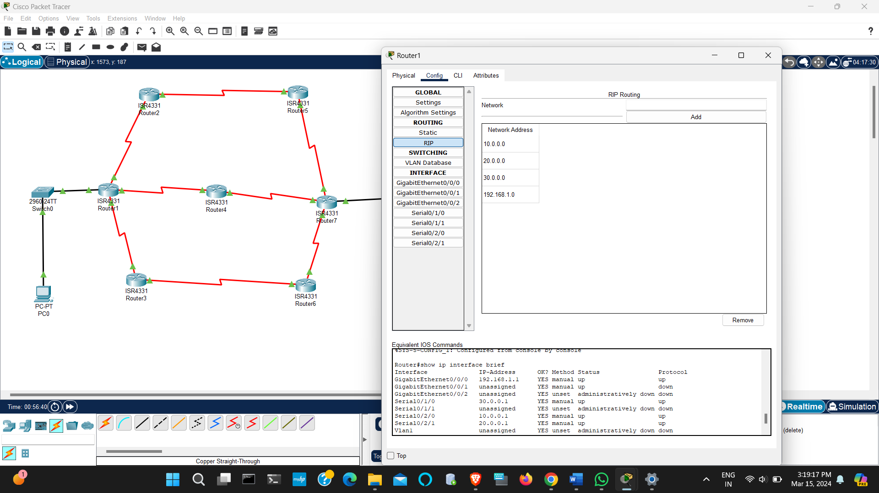

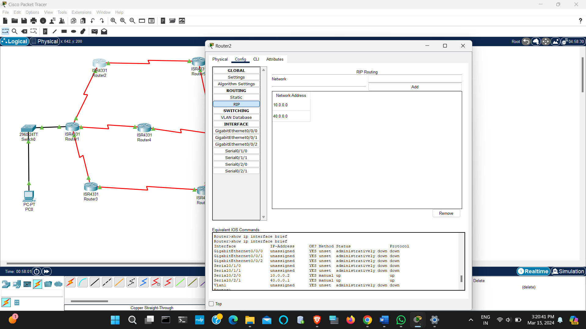

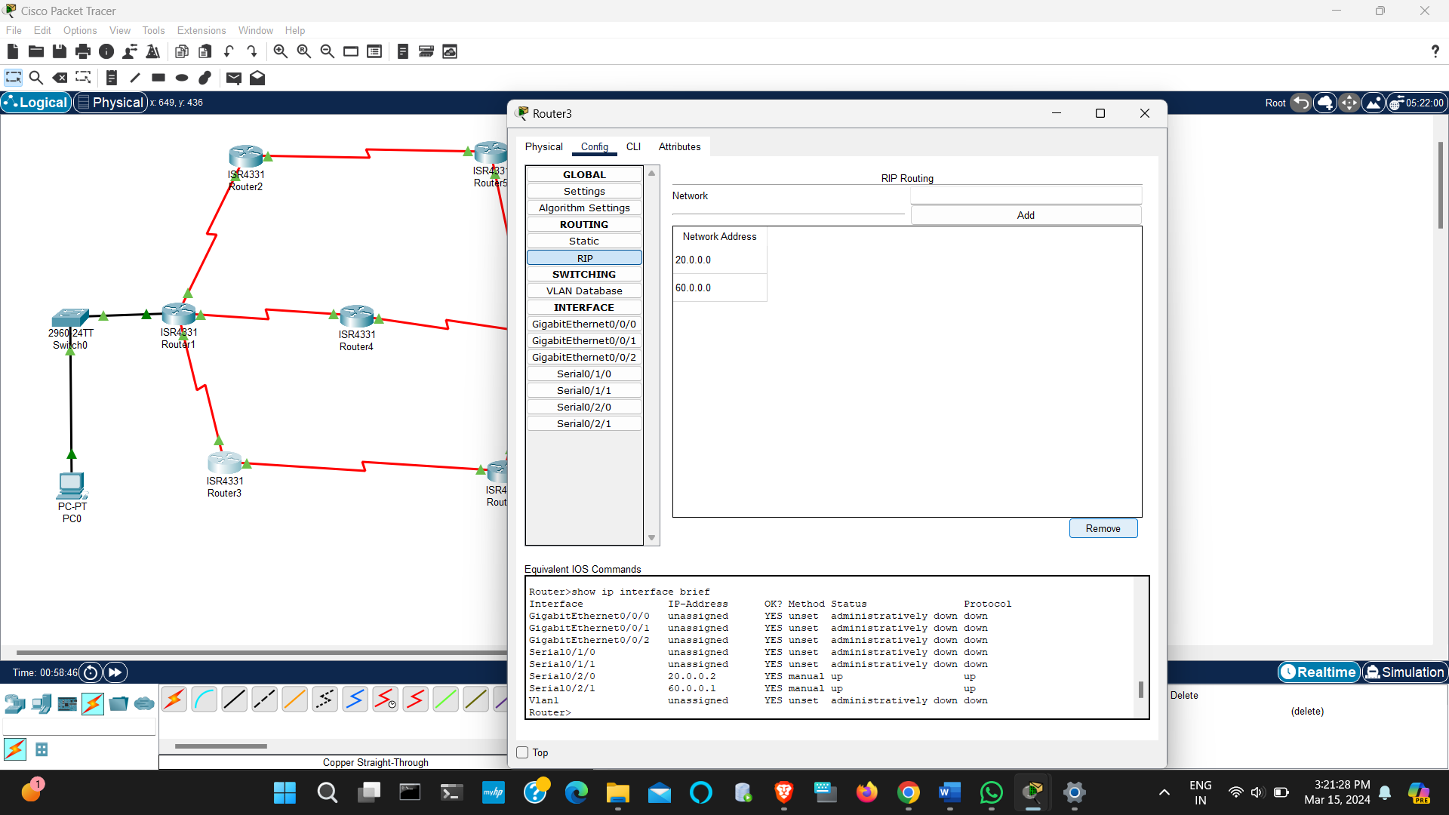

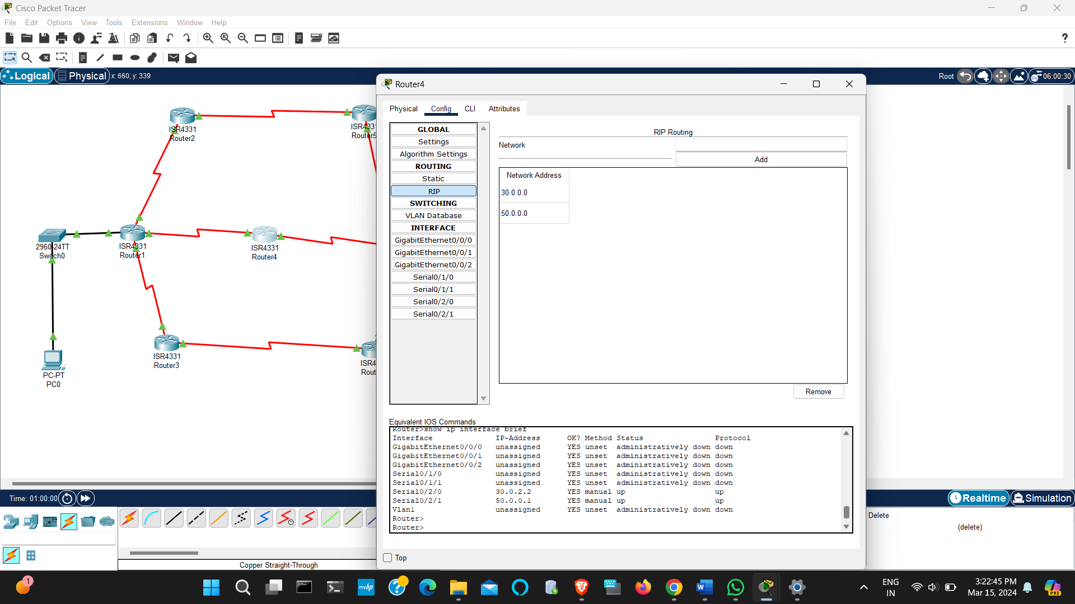

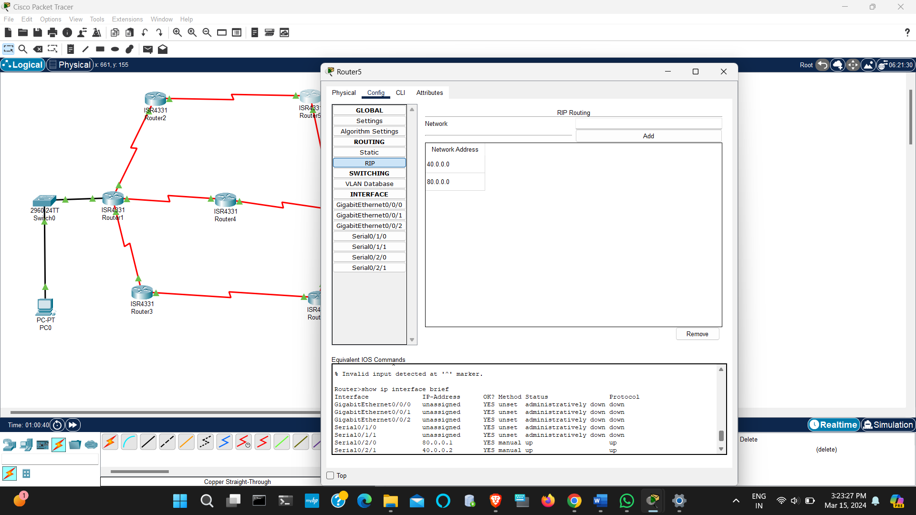

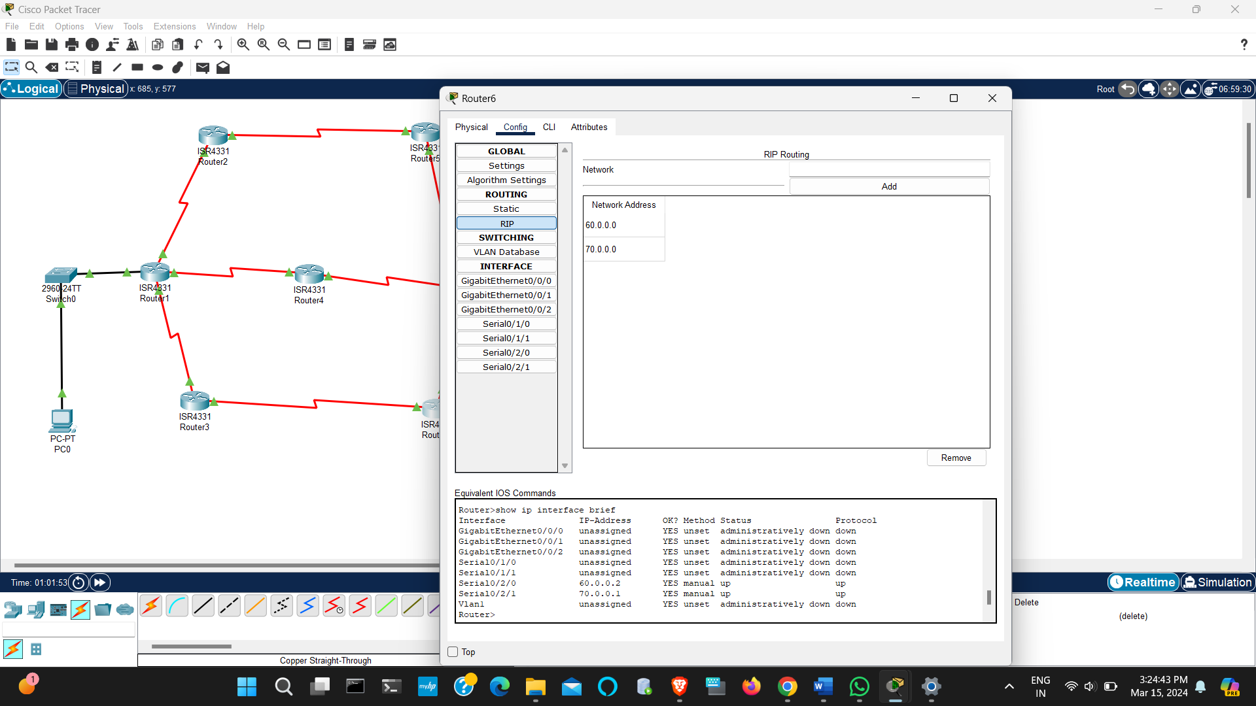

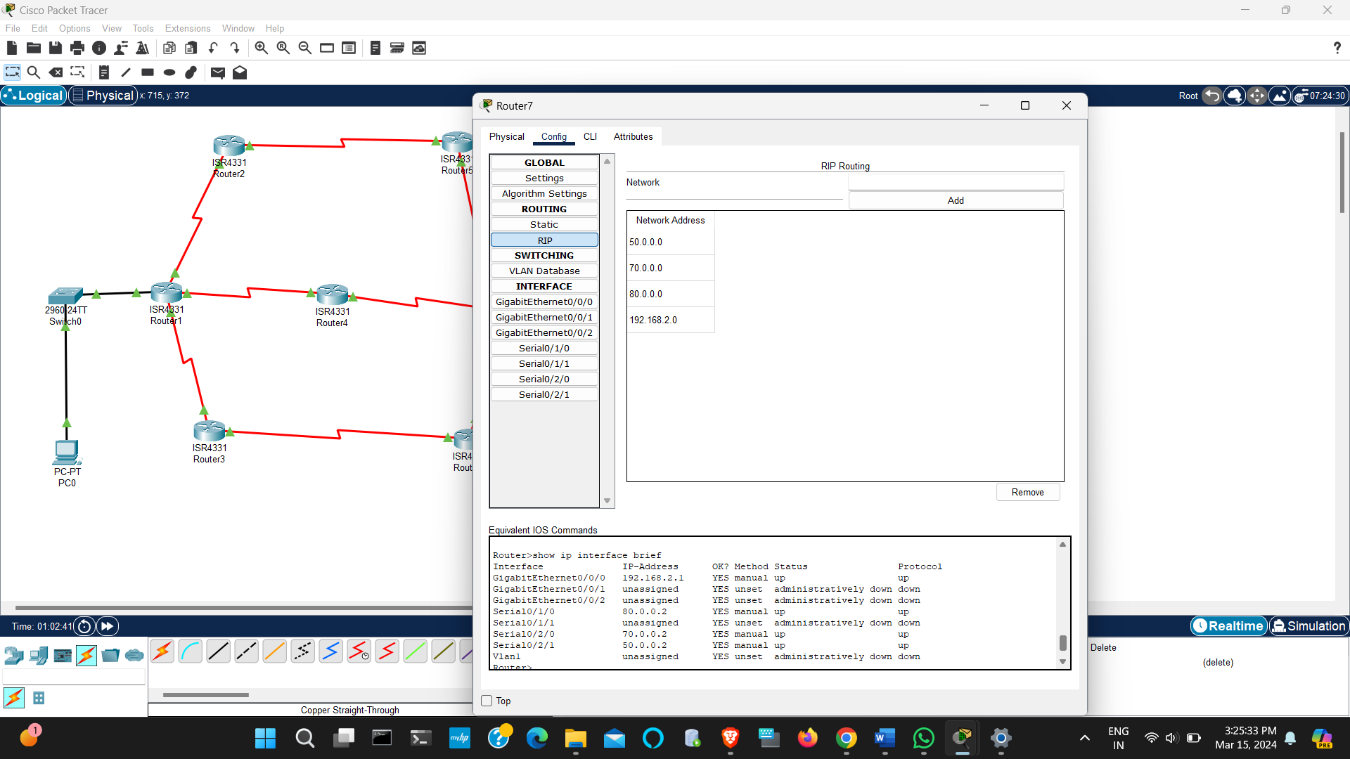

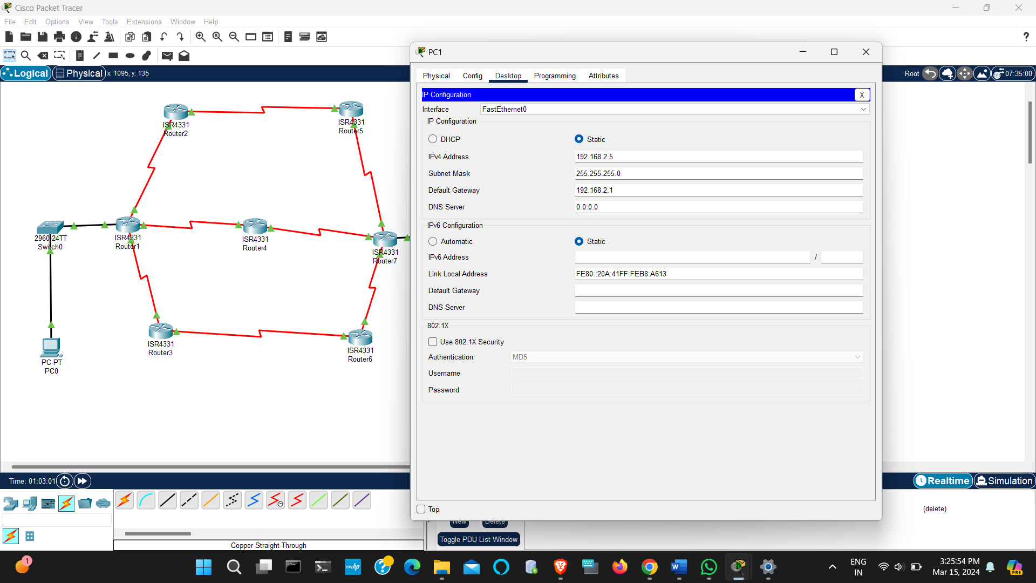

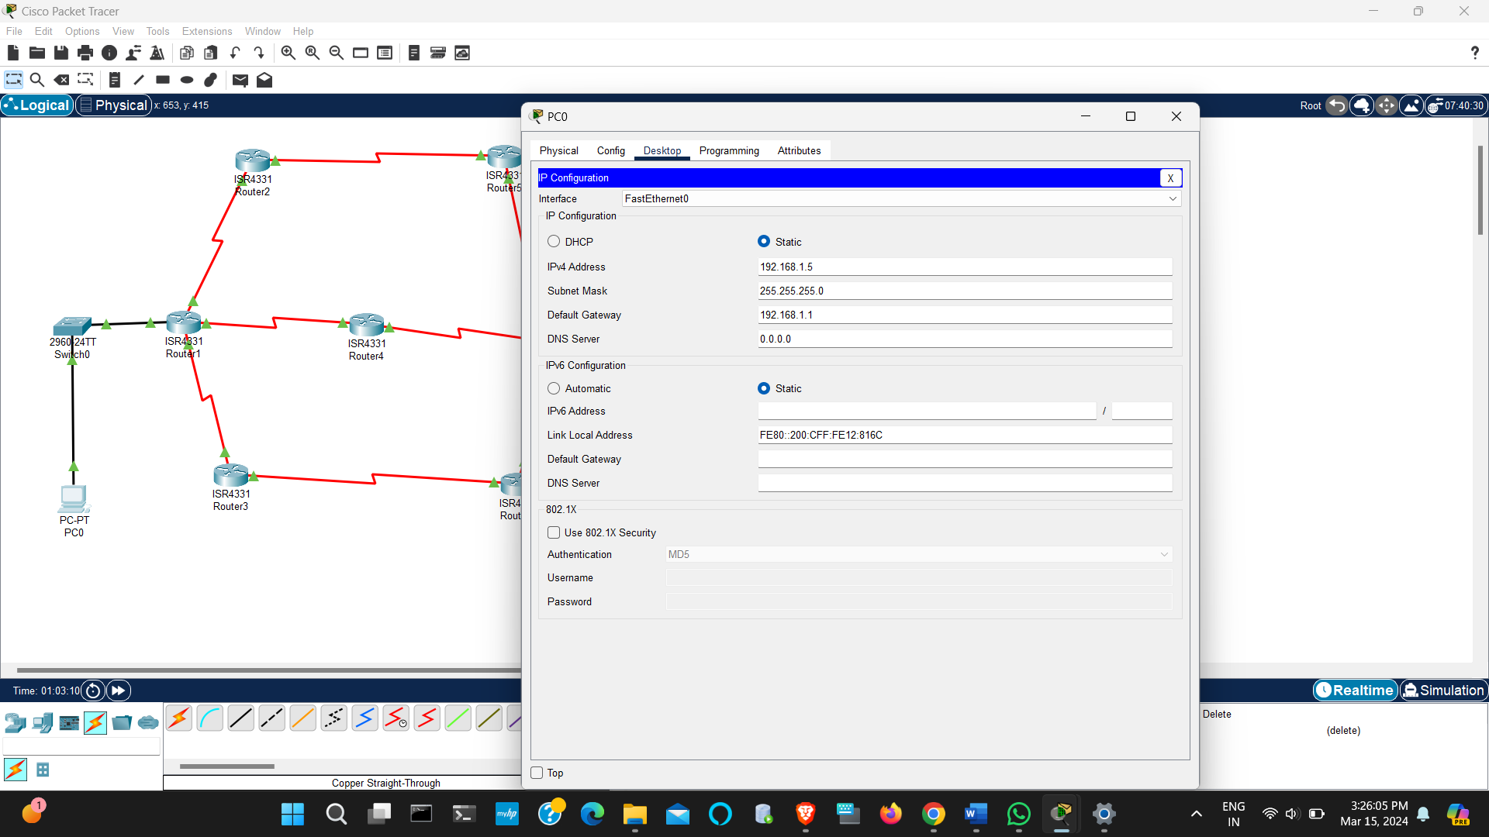

1. Design and configure the following network using RIP Routing protocol.

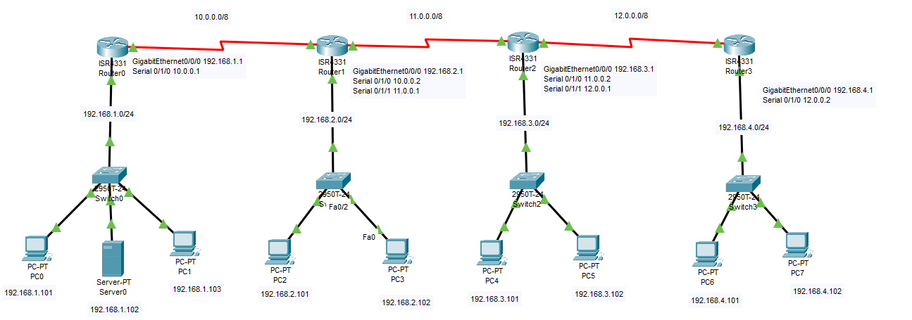

Expected output screenshots:

* 2 success communication from any to any
* 4 router configuration screenshots

